**Azure Data Factory**

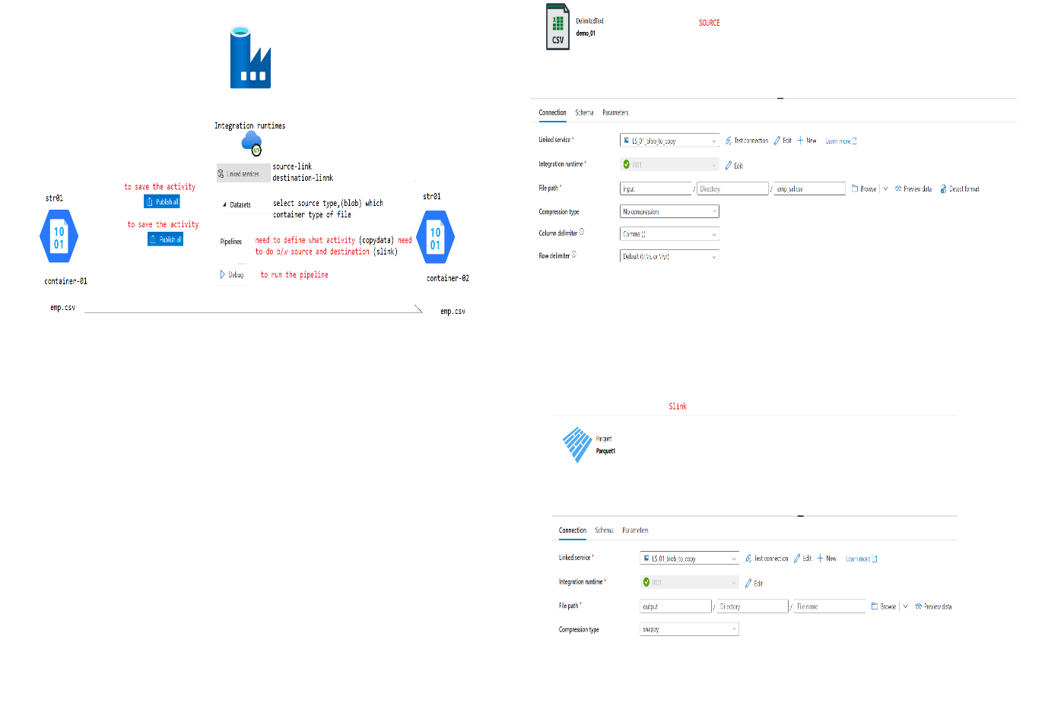

**May 5, 2025**

**MYSQL Content**

create table TBL_1 (ID INT, NAME VARCHAR(20))  
create table TBL_2 (ID INT, NAME VARCHAR(20))

create table TBL_3 (ID INT, NAME VARCHAR(20), CITY VARCHAR(20))  
create table TBL_4 (ID INT, NAME VARCHAR(20), CITY VARCHAR(20))

create table TBL_EMP (EMP_ID INT, EMP_NAME VARCHAR(20))

INSERT INTO TBL_1 VALUES (1,'RAM'),(3,'SHANKAR')

SELECT * FROM TBL_1  
SELECT * FROM TBL_2

SELECT * FROM TBL_3  
SELECT * FROM TBL_4

INSERT INTO TBL_3 VALUES (1,'pushaparaj','chennai'),(2,'priya','chennai')

SELECT * FROM TBL_1  
SELECT * FROM TBL_3

truncate table tbl_1  
INSERT INTO TBL_1 VALUES (1,'RAM'),(3,'SHANKAR')

truncate table tbl_1  
truncate table tbl_2

SELECT * FROM TBL_1  
SELECT * FROM TBL_2

INSERT INTO TBL_1 VALUES (1,'RAM'),(2,'SHANKAR')  
INSERT INTO TBL_2 VALUES (1,'AA'),(2,'BB')

truncate table tbl_1  
truncate table tbl_2

INSERT INTO TBL_1 VALUES (1,'RAM'),(2,'SHANKAR'),(4,'PUSHPARAJ')  
INSERT INTO TBL_2 VALUES (1,'AA'),(2,'BB'),(3,'PRIYA')

SELECT * FROM TBL_1  
SELECT * FROM TBL_2

**5 days Before May 22:**

**create table employee(id int, name varchar(128), country varchar (128) )**

**insert into employee values (1,'ram','india')  
insert into employee values (2,'shanker','india')  
insert into employee values (3,'ram','Srilanka')  
insert into employee values (4,'ram','singapore')  
insert into employee values (5,'raje','india')  
insert into employee values (6,'ram','SA')**

**select * from employee**

**create procedure emp_delete @id int as  
delete from employee where id=@id**

**select * from employee**

**exec emp_delete @id=1**

**create table emp_res(id int)  
insert into emp_res values (1),(2),(3)**

**select * from employee  
select * from emp_res**

**May 22:**

create table sales(  
product_id int,  
product_type nvarchar(128),  
sales_price int,  
salestime datetime  
)

insert into sales values (1, 'tv', 30000,'2025-05-01 00:04:07.001')  
insert into sales values (1, 'cooler', 50000,'2025-05-01 00:04:07.001')  
insert into sales values (1, 'hdtv', 18000,'2025-05-01 00:04:07.001')  
insert into sales values (2, 'stv', 30000,'2025-05-02 00:04:07.001')  
insert into sales values (2, 'tab', 30000,'2025-05-02 00:04:07.001')  
insert into sales values (2, 'basic mobile', 30000,'2025-05-02 00:04:07.001')  
insert into sales values (3, 'smart mobile', 30000,'2025-05-03 00:04:07.001')  
insert into sales values (3, 'desktop', 30000,'2025-05-03 00:04:07.001')  
insert into sales values (3, 'laptop', 30000,'2025-05-03 00:04:07.001')  
insert into sales values (4, 'tv', 30000,'2025-05-04 00:04:07.001')  
insert into sales values (5, 'tv', 30000,'2025-05-05 00:04:07.001')

select * from sales  
where salestime between '2025-05-01 00:00:00.00' and '2025-05-02 00:00:00.00'

create procedure str_sales  
@startdate varchar(128),  
@enddate varchar(128)  
as begin  
select * from sales  
where salestime between @startdate and @enddate end

exec dbo.str_sales '2025-05-01T00:00:00.00' ,'2025-05-02T00:00:00.00';



